**Peoria Civic Hackathon Submission**

### This is team Working As Designed’s submission for the Peoria Civic Hackathon.

**Description**

Our project is a mobile app (and supporting web page) called Peoria City Worx.

It is the product of our work based on the following Value Statement.

|  |  |
| --- | --- |
| **Epic Value Statement** |  |
| **For** | residents of the City of Peoria, IL |
| **who** | travel about the city for work and/or recreation |
| **the** | Working As Designed project |
| **is a** | interactive, technology system |
| **that** | provides a mechanism for awareness of current and planned infrastructure projects that effect them. |
| **Unlike** | the current, distributed means of getting this information via door hangers, newspaper, TV, radio, social media, little yellow signs, |
| **our solution(product)** | provides this information all in one place when and where the residents need it. |

**Screenshots**

Project filter menu

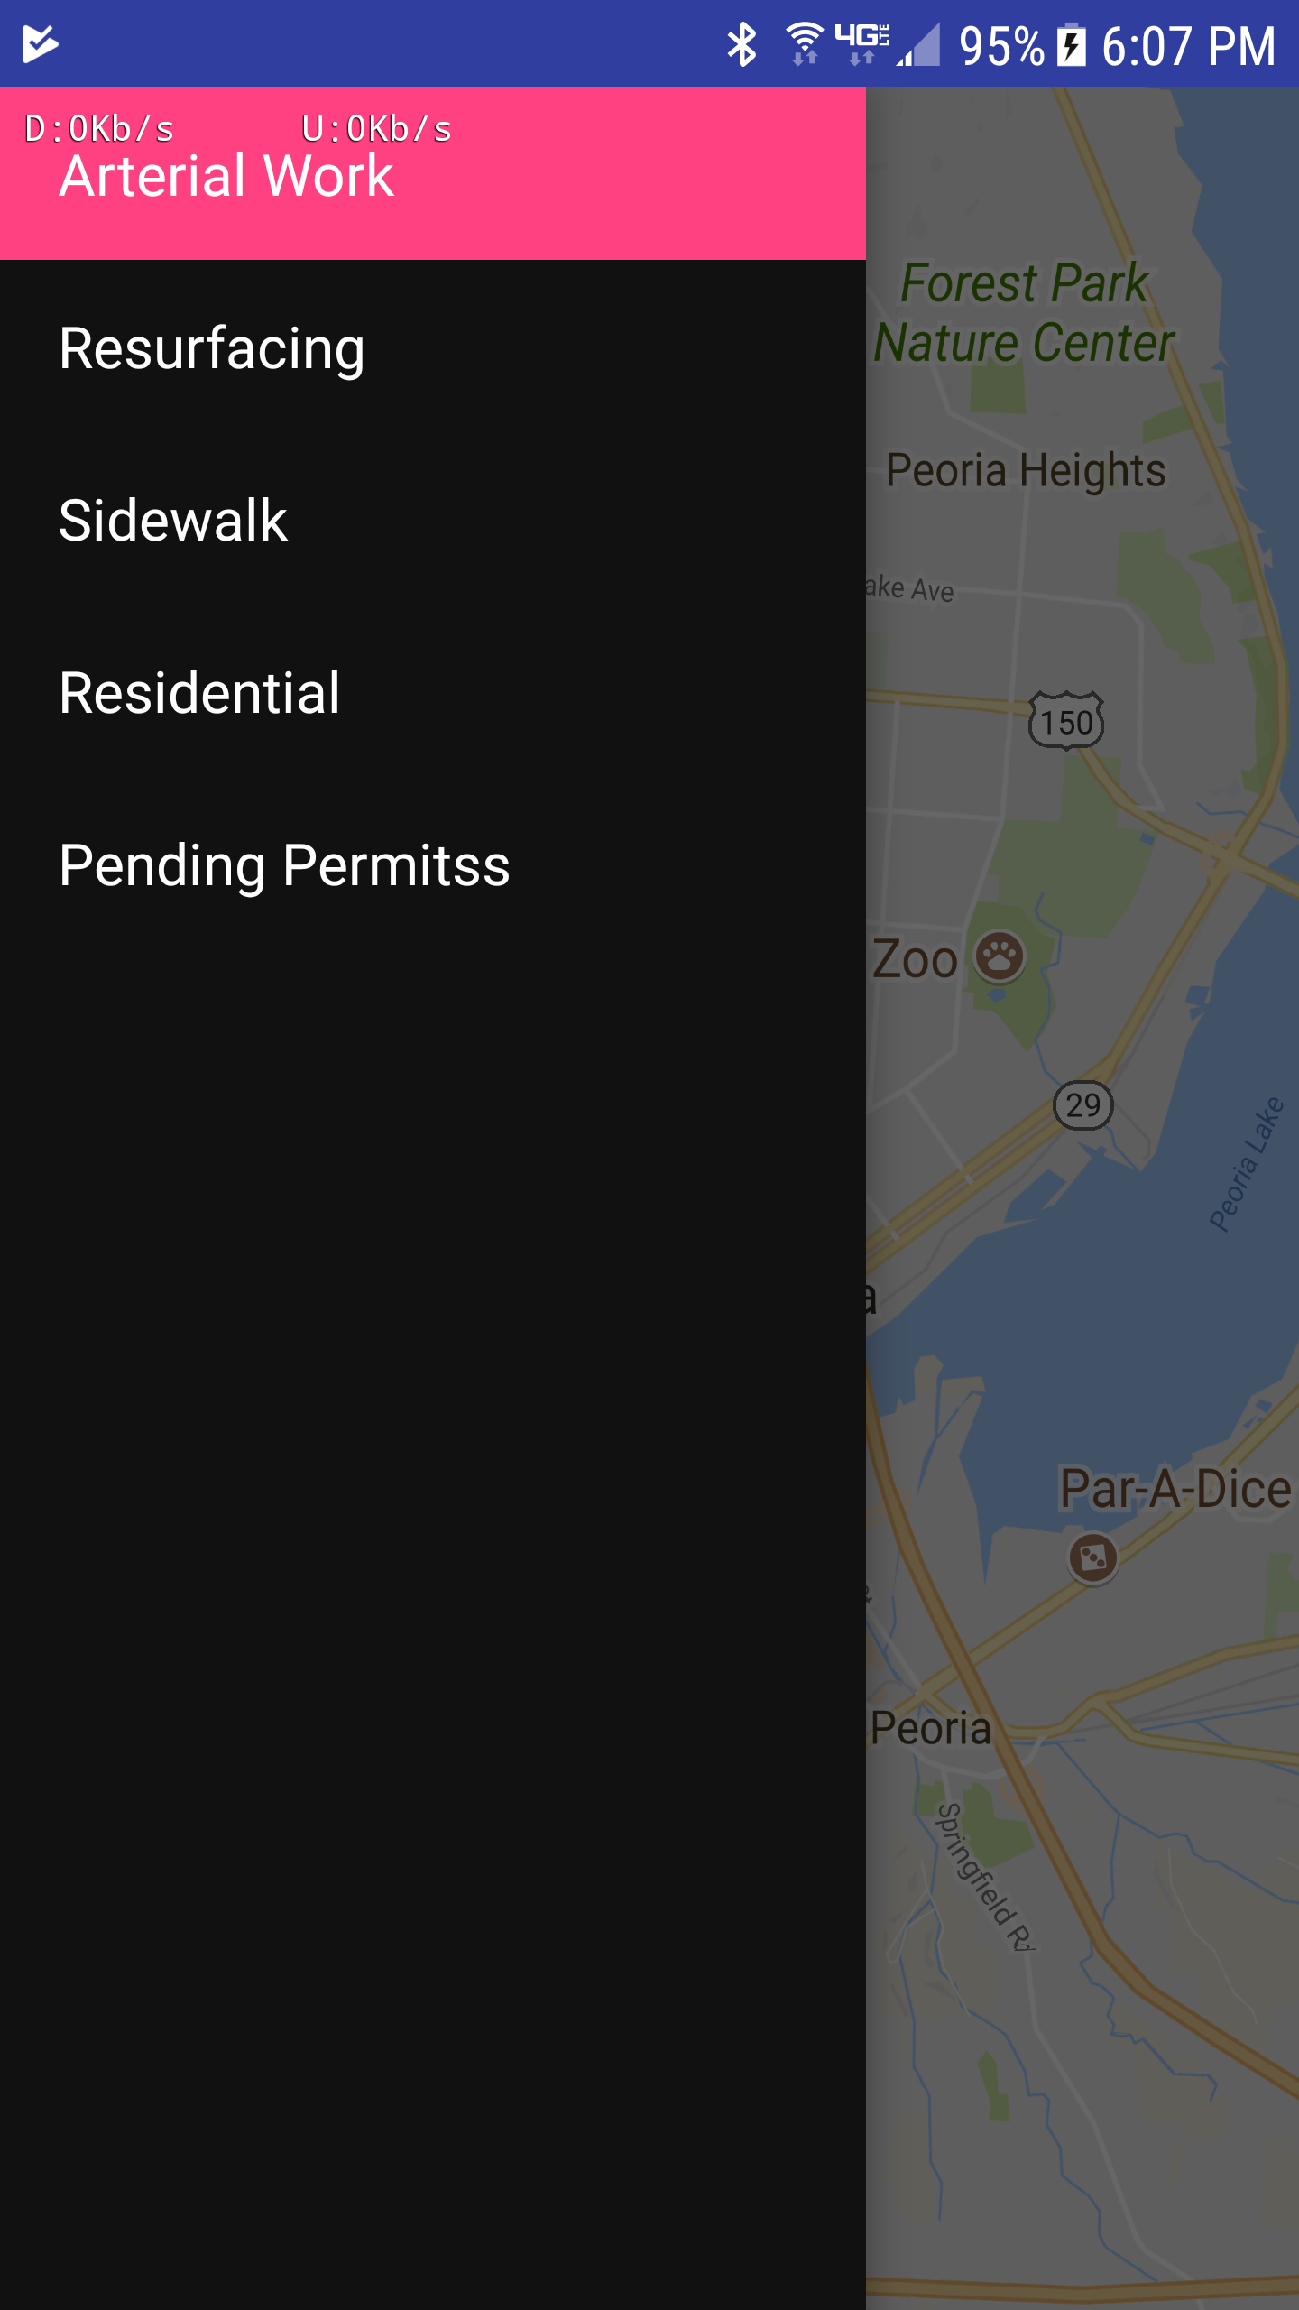

Projects highlighted

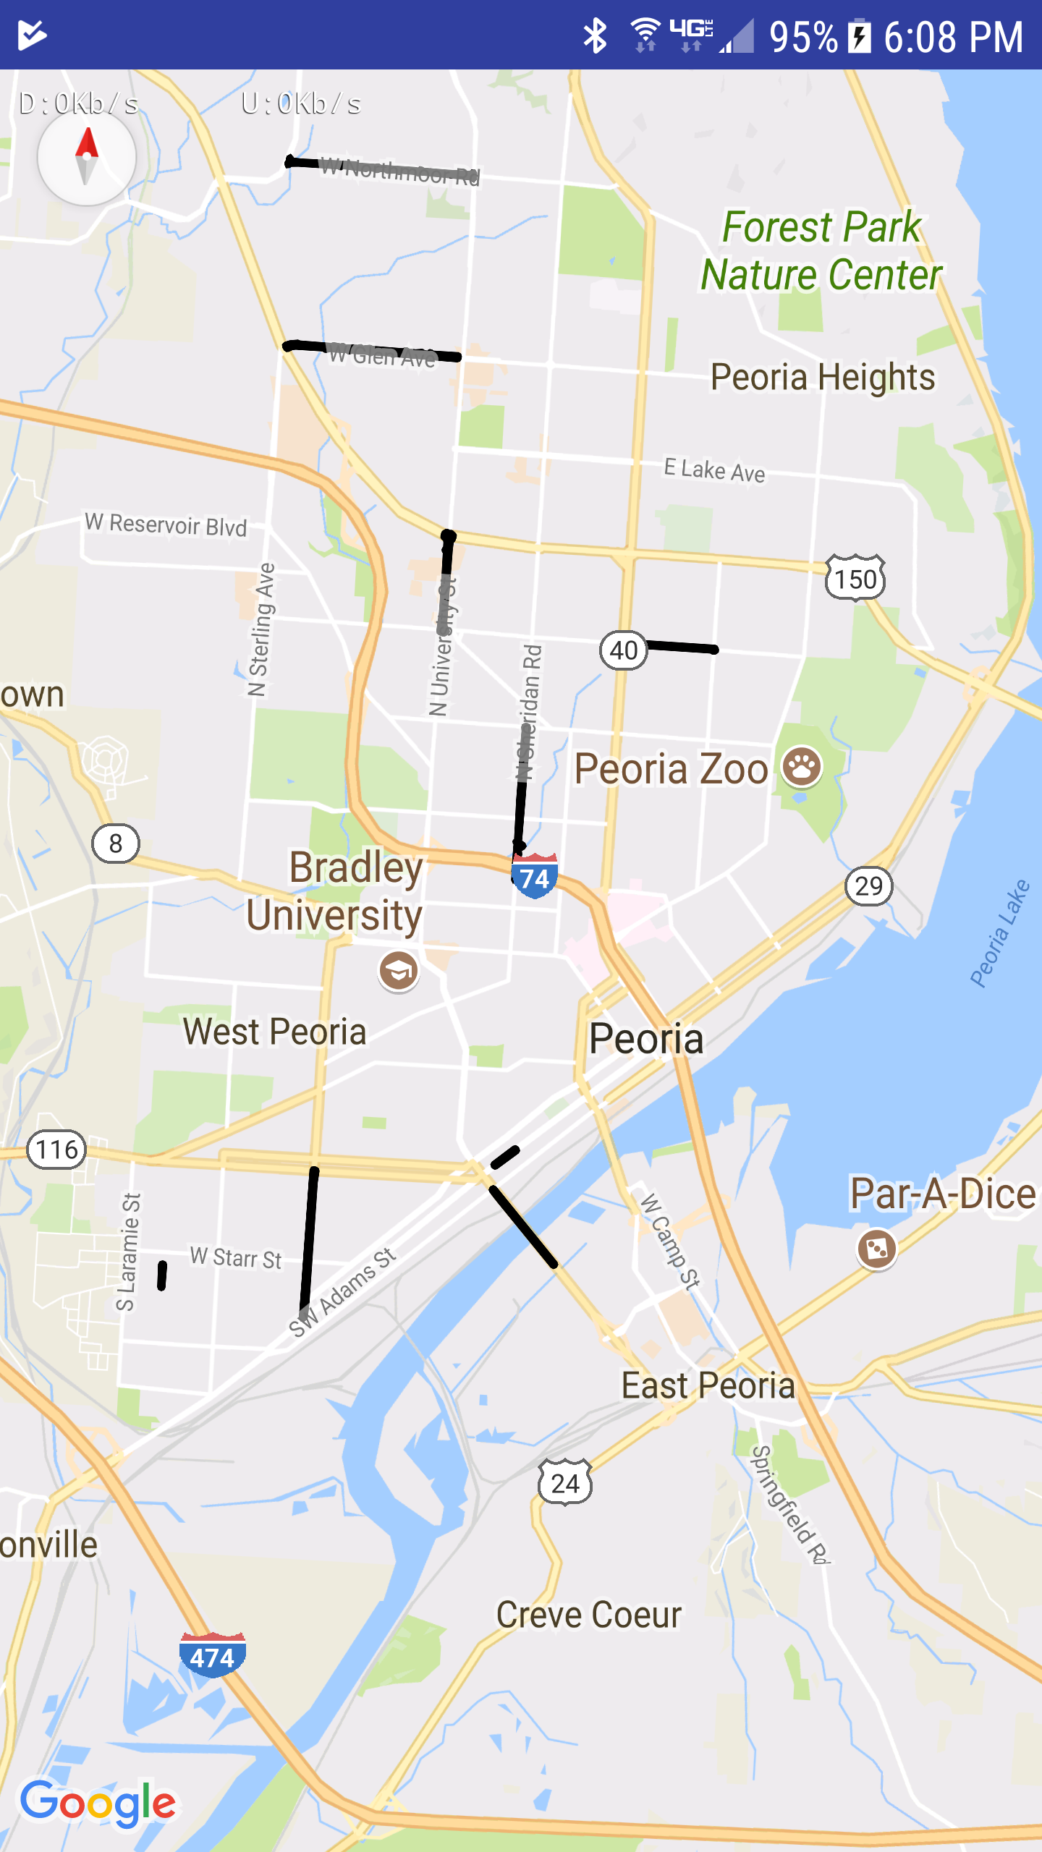

Project status

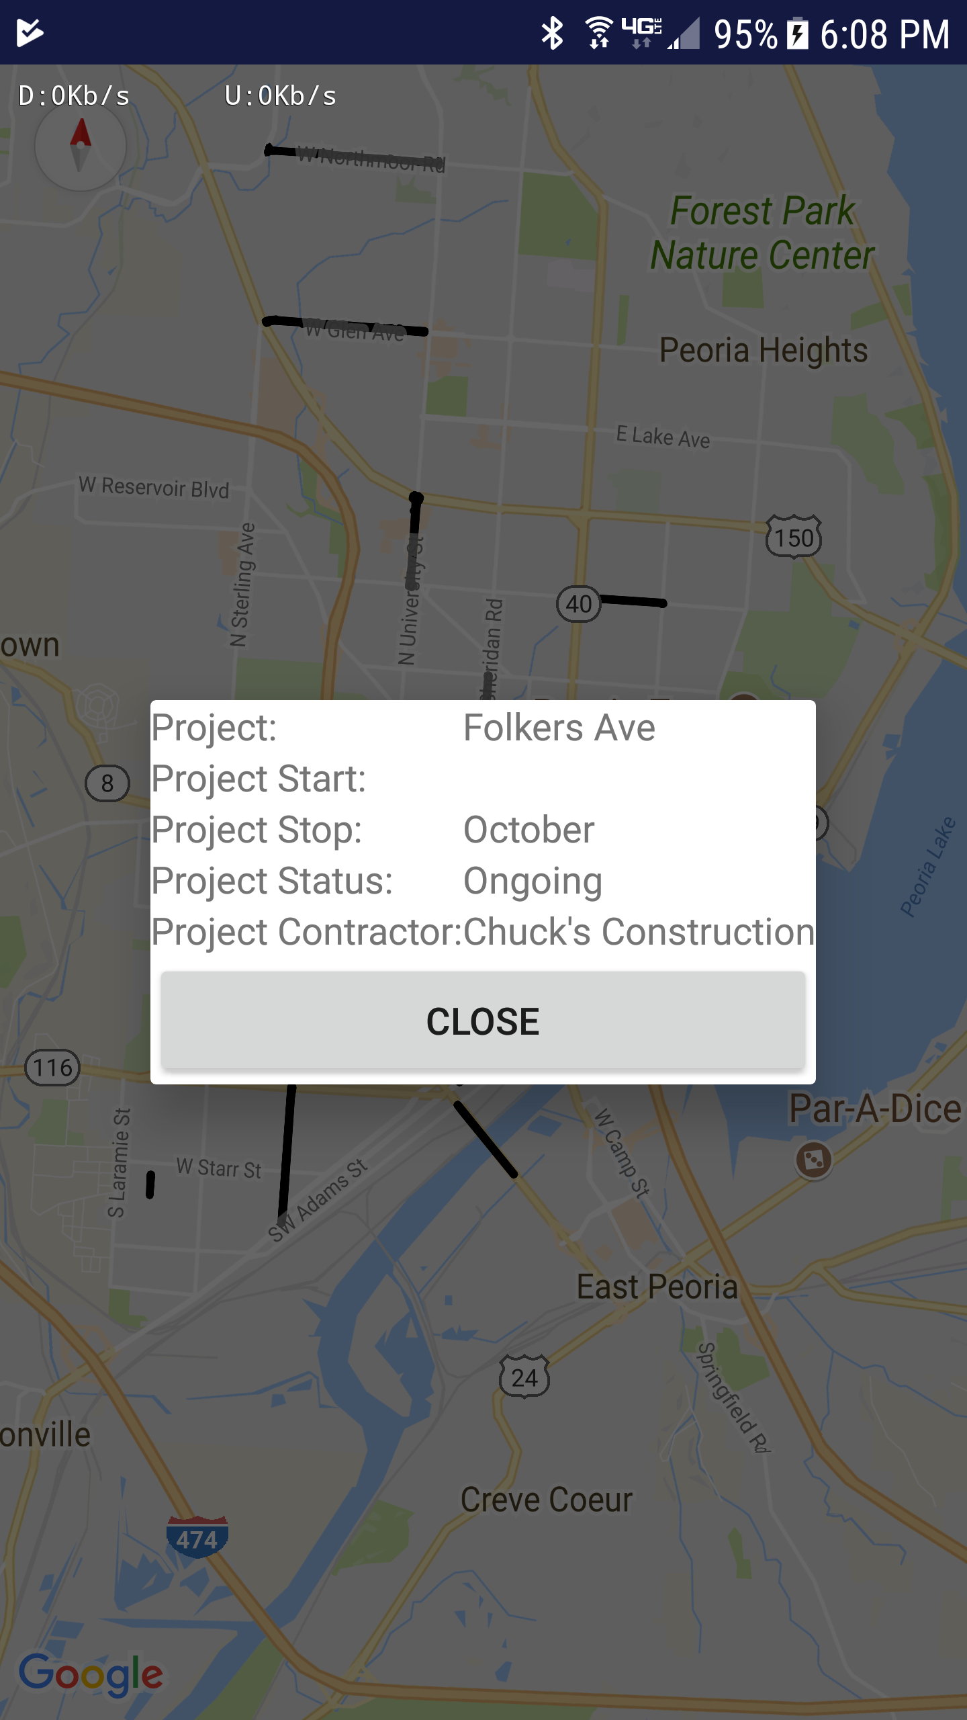

**Data/APIs used**

We used the following data sets provided by the City of Peoria.

* Arterial Reconstruction
* Pavement Projects 2017
* Ramp Construction (Faked for Permits)
* Residential Reconstruction
* Sidewalk Construction

We used the Google Maps API.

**Team Members**

* Dan Adler (<https://github.com/danergy1409)>
* Bradley Bergerhouse (<https://github.com/bergebf)>
* Stacy English (NA)
* Ryan Funk (<https://github.com/kibitzforu)>
* Jeff Rule (<https://github.com/rulejd)>
* Eric Spurgeon (<https://github.com/espurgeo)>
* Arjun Veneshetty (<https://github.com/bharana)>